**Shop-Drop**

Submitted by:

|  |  |  |
| --- | --- | --- |
| Student Name | Student Roll No. | Exam Seat  No. |
| Atharva Joshi | 05 | BBACA205 |

Year & Semester: 3rd Year 1st Semester

Division: A

Brihan Maharashtra College of Commerce

Date of submission: 01/04/2023

Abstract

The purpose of the project entitled as “Shop-Drop” is to allow individuals to carry out purchase of goods anytime and anywhere using hand held mobile devices. The basic concept of the application is to allow the customer to shop virtually using the internet and mobile devices and allow the customer to buy items of their desire from the store. The information pertaining to the products are stored on an real-time database at the server side(store). The details of the items are brought forward from the database for the customer view based on the selection through the menu.

TABLE OF CONTENTS:

|  |  |
| --- | --- |
| Sr no. | Title/particulars |
| 1 | Introduction |
| 2 | Objectives |
| 3 | Scaling |
| 4 | Methodology |
| 5 | Limitations/Assumptions |
| 6 | Technology used |
| 7 | Methodology |
| 8 | Project Screenshots |
| 9 | Diagrams |
| 10 | Database Screenshots |

Introduction

Shop-Drop is an online shopping store which allows an offline store owner to put up his entire store on the mobile devices through the use of internet. The objective of this project is to create an e-commerce application which would allow product information to be displayed to the user on a hand held mobile device. The application will have an interface that will allow the user to buy goods from the store owner, completely online without having the need to visit the store in person. There are two types of users available in the project. First one is the customer and the second one is the admin. Customers user have limited access right to the system while the admin user has full control over the system.

I have used Dart for the enitre coding aspect which includes structure and designing the application as well as integrating the backend. Firebase has been used as the backend for this version of the project.

Objectives

The project objectives are:

* To make shopping easier and comfortable
* To serve the customer without wasting their precious time
* To deliver the products to the customers address with great care
* To enable the customers to access the store from anywhere and at any time.

Scaling:

1. Self-selection: The application focuses on the users selecting all the services through a process.
2. Shop-Drop and its operations are limited to India only. International operations will added too!
3. Future updates will include UI changes, discounnt coupons,more payment options.

Limitations:

1. The user has to login or signup to enter the application
2. Only cash on delivery option is available as of now.

Assumptions:

1. The user has an active internet connection
2. The user is using android verion 7.0 and above

Technologies Used:

**A.] Plugins :**

1. cupertino_icons: ^1.0.2
2. velocity_x: ^3.6.0
3. get: ^4.6.5
4. path_provider: ^2.0.11
5. firebase_core: ^2.4.0
6. firebase_auth: ^4.2.0
7. firebase_storage: ^11.0.7
8. cloud_firestore: ^4.2.0
9. image_picker: ^0.8.6
10. url_launcher: ^6.1.7

**B.] Languages:**

1. Dart has been used for developing the entire application which includes the structure, designing and backend integration

2. JavaScript has been used for styling few aspects of the application.

3. FireBase has been used as database which includes a real time database

**C.] IDE – Visual Studio Code(2022)**

**D.] Repository – Github**

Methodology

1. What is Shop-Drop?

* Shop-drop is an online e-commerce mobile application where the buyer is carrying out trade without having to visit the shop of the seller physically. The seller tends to the need of the buyer online. There is no intermediary service. The sales and purchases transaction is completed electronically and interactively in real-time. The development of the application contains the following activities. User gets its email id and password to access their account. Administrator of shopping cart system has multiple features such as Add, Delete, Update product category.

1. Features of Shop-Drop:

* Secure registration and profile management facility for customers.
* Browsing through the application to see the items that are there in each category of products.
* Creating shopping cart so that customers can shop N number of items and checkout finally with the entire shopping cart.
* Customers should be able to contact the shop about the items that they would like to see in the shop.
* Uploading most purchased and featured items to respective categories

1. Software Requirement:

* Device with android version 7.0 and above
* Active internet connection
* WhatsApp to chat with the vendor
* Instagram to visit the vendors social handle.

1. User of Shop-Drop:

* There are two types of users available in this project:
* **Customer : with limited access**
* **Admin: with full acces**

1. Functionality performed by Customer user:

* Registration for customer
* Login for customer
* Forgot password for customer
* Edit profile for customer
* View bill [the bill is a fully functionaly receipt that contains the payment status and state of order]
* Browse products
* Add/Remove products from shopping cart
* Add/Remove products from wish list
* Chat with admin through whatsapp

1. Functionality performed by Admin user:

* Login for admin
* Forgot password for admin
* Add/Delete products to particular categories
* Make product top category
* Make product featured
* Manage users
* Communicate with users through whatsapp for any queries.
* Update payment status
* Accept orders
* Update order delivery status
* Edit profile

Project Screenshots

**User Application:**

1. Login and Signup page:

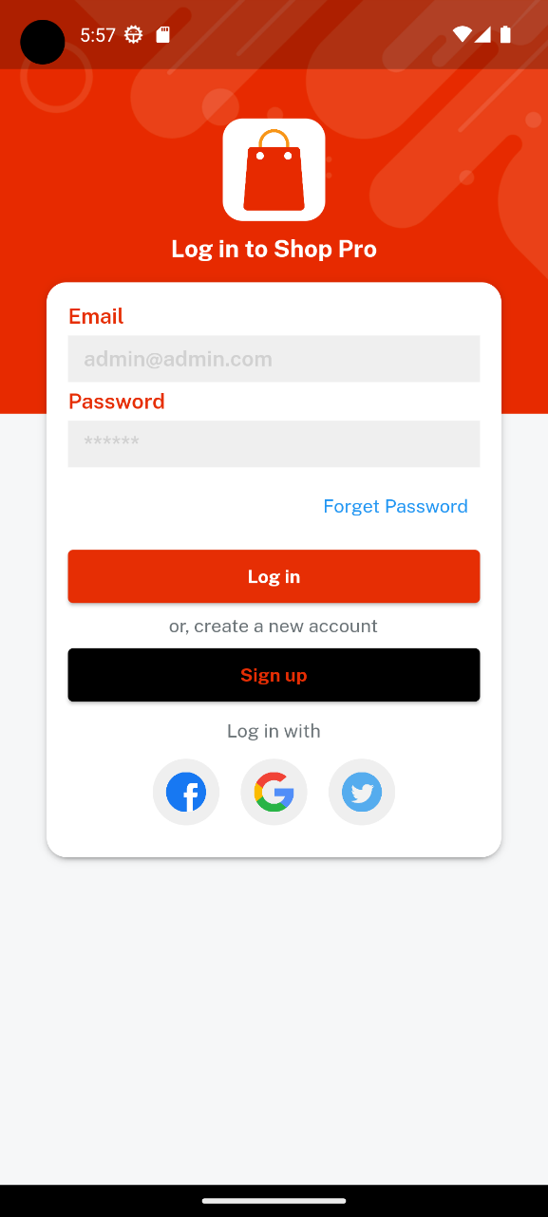 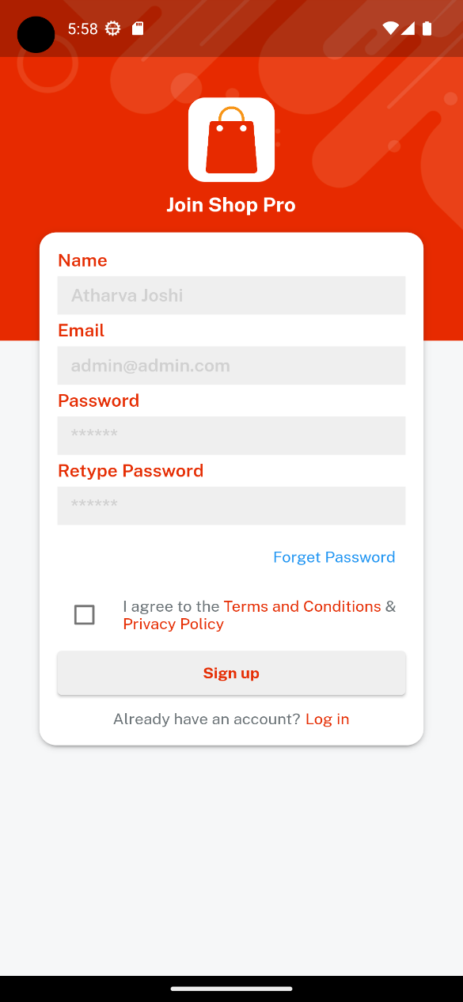

* Upon opening the app the user will see a splash screen and will be prompted with the login screen.
* If the user has an account he can directly login or can sign-up from the sign up screen.

1. Forgot password:

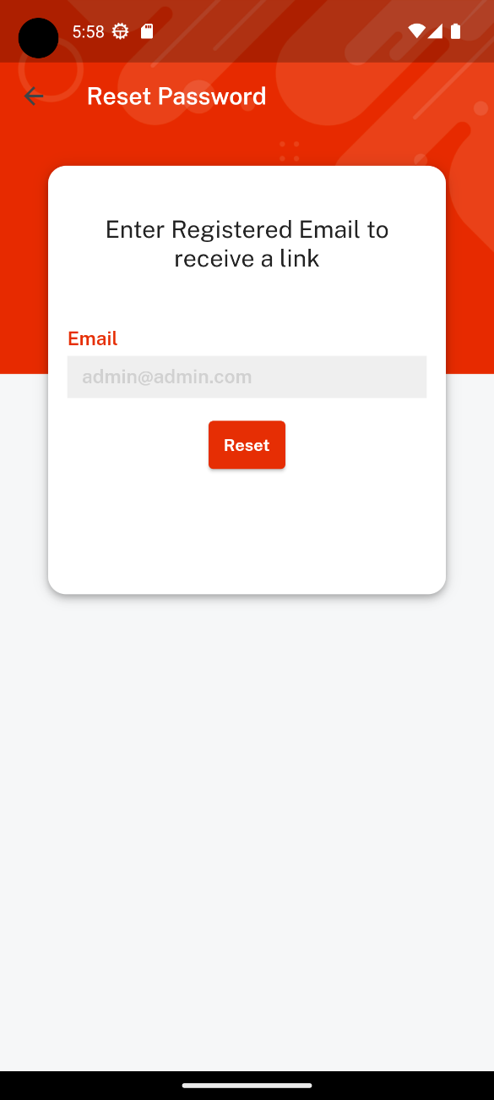

* If the user has forgotten the password, he can click on the forgot password link in th login page and will be redirected to this page where he can enter his registered email and a link will be sent to his email-id to reset the password.

1. Home Screen

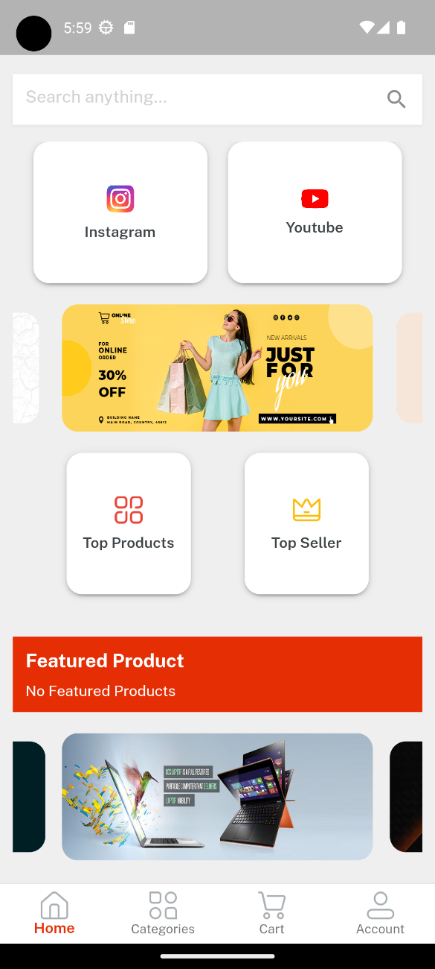 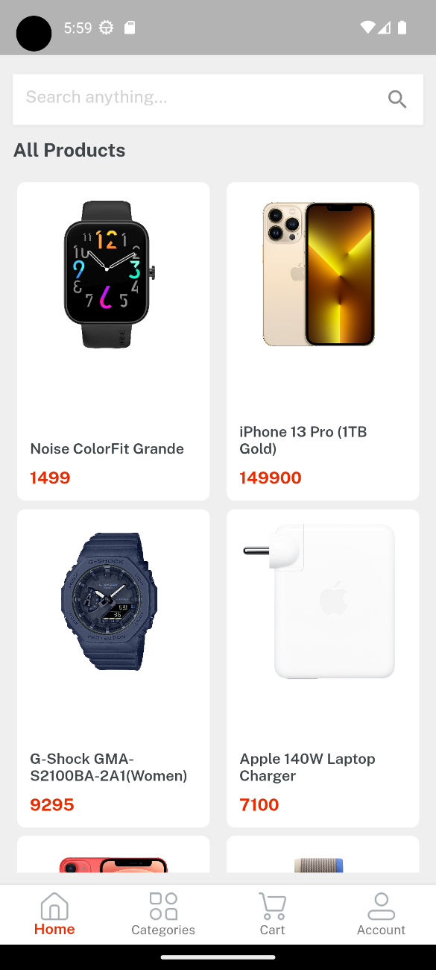

* Upon logging into the app the user will land on the homescreen where he will be able to see all the products provided, some banner images, social links to keep up with the application and few buttons along with the floating search bar.
* The bottom navbar is maintained on every page.

1. Categories screen:

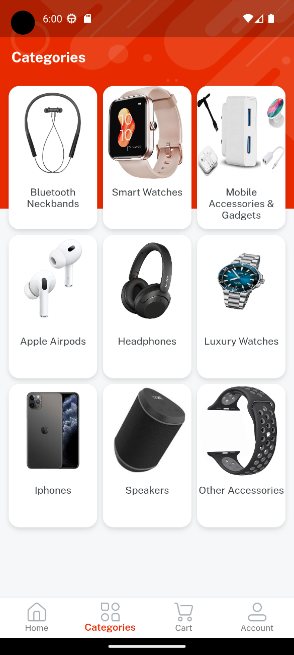 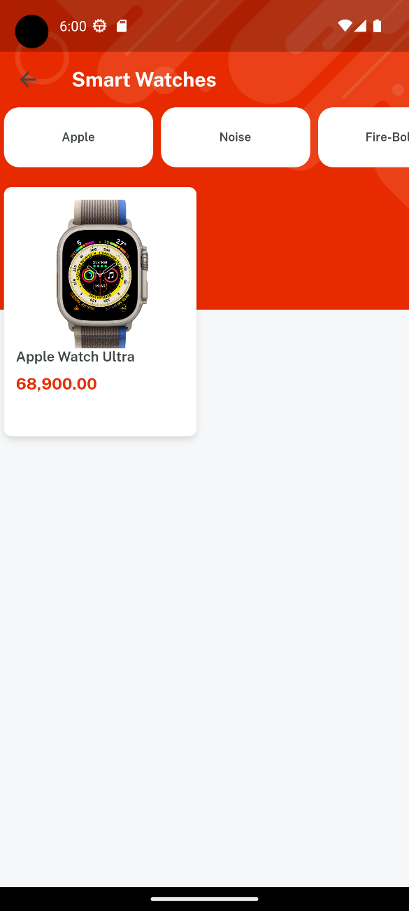

* In the categories screen 9 categories are provided to the user. On clicking on particular category the user will head inside that category and will be able to see all the products belonging in the specific category along with the option to filter the product as shown in the second image.

1. Product details screen:

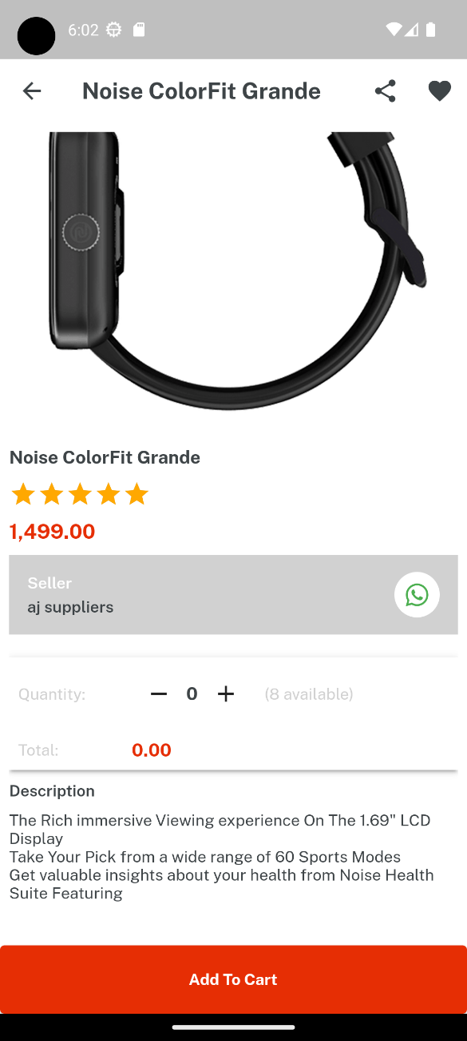

* This is the product details screen where in the user can view the product details. The page has a slider that consists of 3 images which keep on changing every 5 seconds. The whatsapp button allows the customer to contact the seller in case of any queries about the product. The product can then be added to the cart if only a quantity above 0 is selected. The heart icon on the top allows the customer to add the product to his wishlist.

1. Wishlist screen:

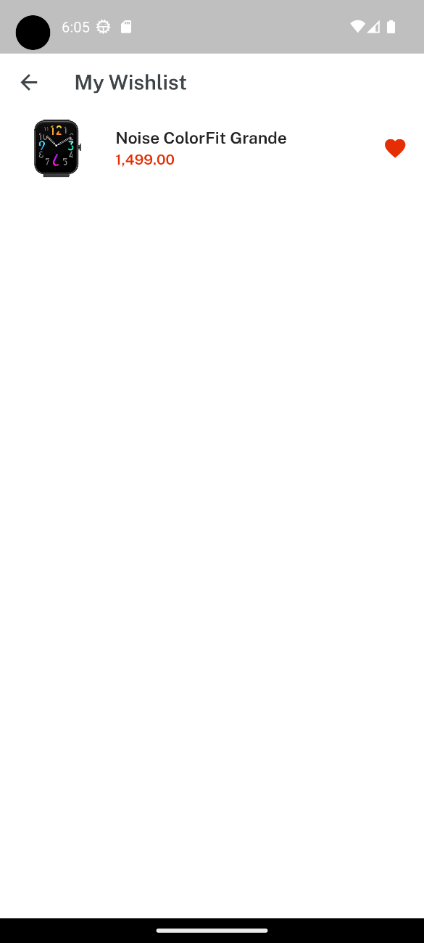

* The product added to the wishlist can be removed, by clicking on the heart icon. Adding the wishlist items to the cart will be added in the future updates.

1. Cart Screen:

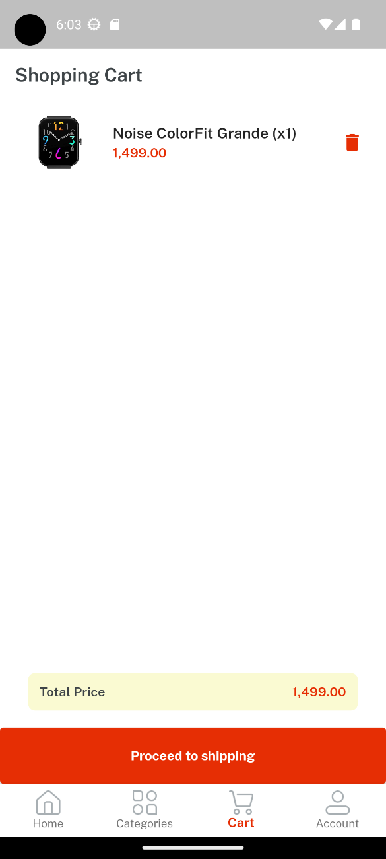

* The cart page allows the user to see all the items chosen with the total on bottom. The total is dynamic and keeps on changing as items are added or deleted from the cart. The items in the cart can be remove by clicking on the trash icon simply. Clickin on proceed to shipping will redirect the user to the shipping page.

1. Shipping screen:

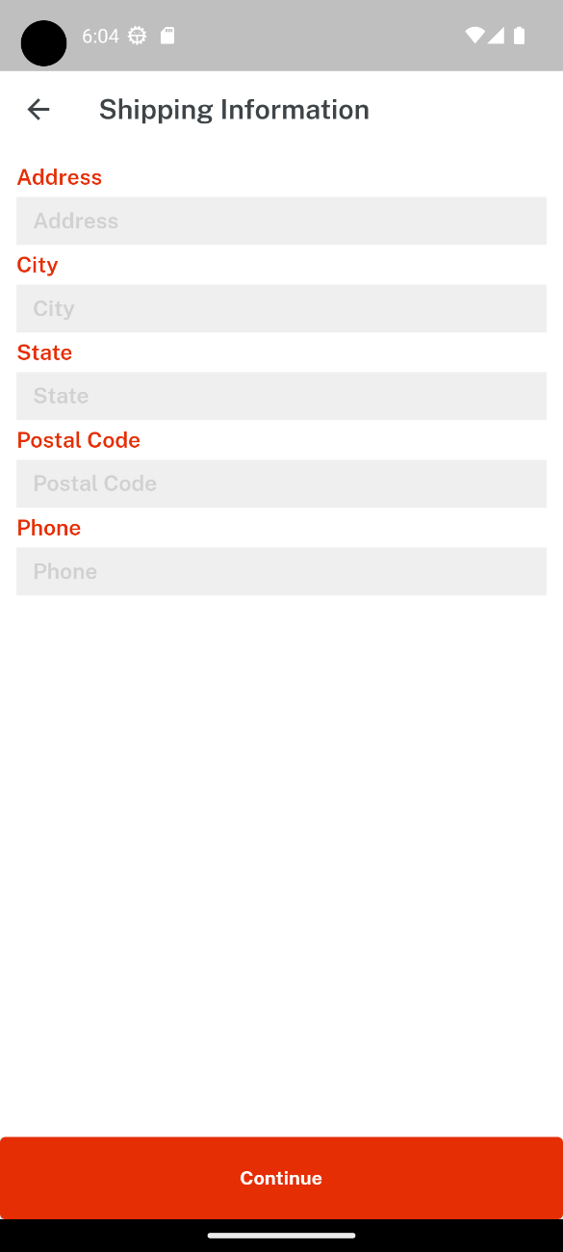

* The user has to fill in the following details for the product he orders to reach his doorstep. The information filled will be added to the receipt.Phone number validation has been added so that the user doesn’t enter a wrong number i.e 10 digit phone number is needed otherwise the user wont be able to proceed.

1. Payment Method:

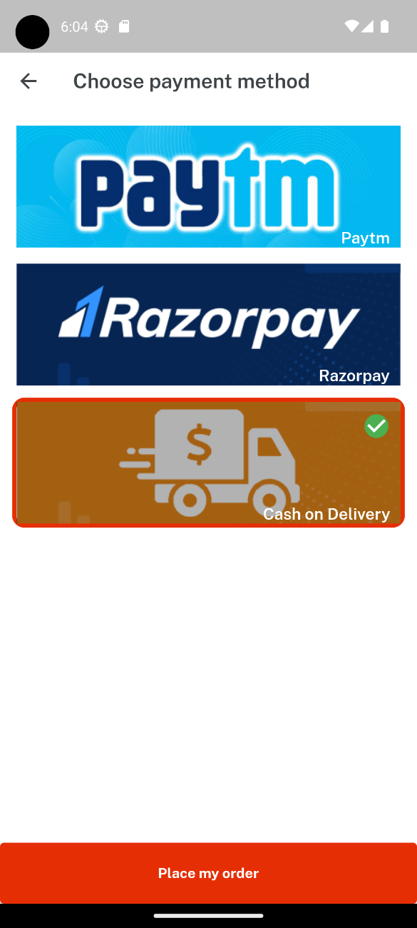

* As of now only cash on delivery method is integrated into the application and razor pay and UPI options are being worked upon and will be available in the future version. As the user chooses the payment method and clicks on place my order the order will be placed and the user will be redirected to the home screen.

1. Profile Page:

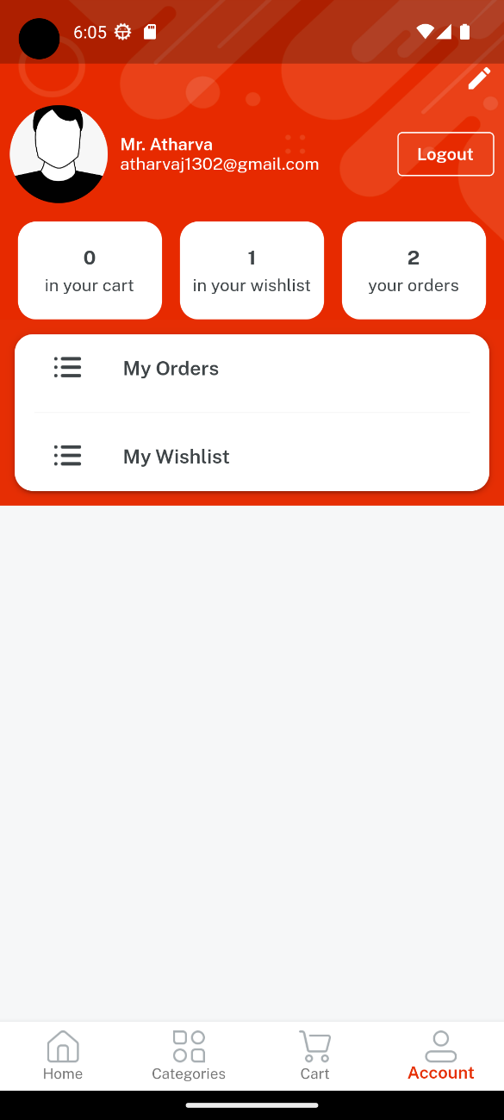

* The user profile consists of various functionalities which includes editing the user profile, logout from the app, the number of items that reside in the shopping cart, the number of items residing in the wishlist, the number of order placed, buttons to view wishlist and orders placed.
* The users name,email address and profile are also visible in the left hand top corner.

1. Orders and Receipt page:

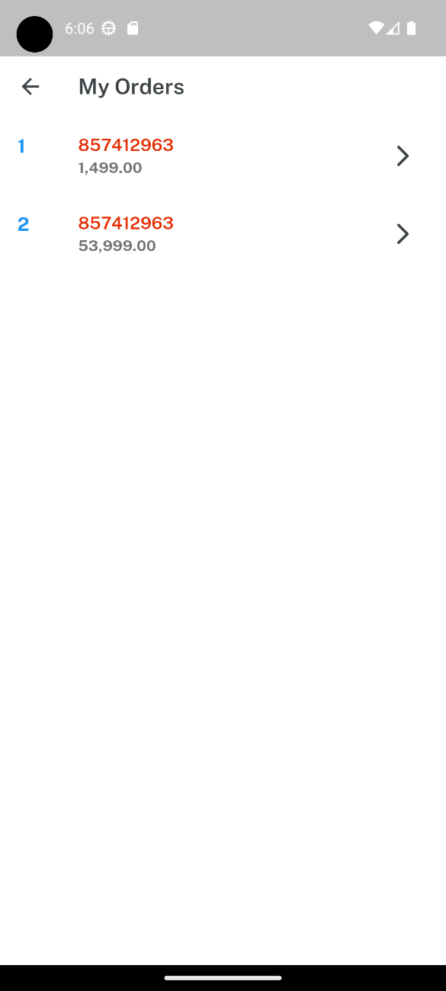 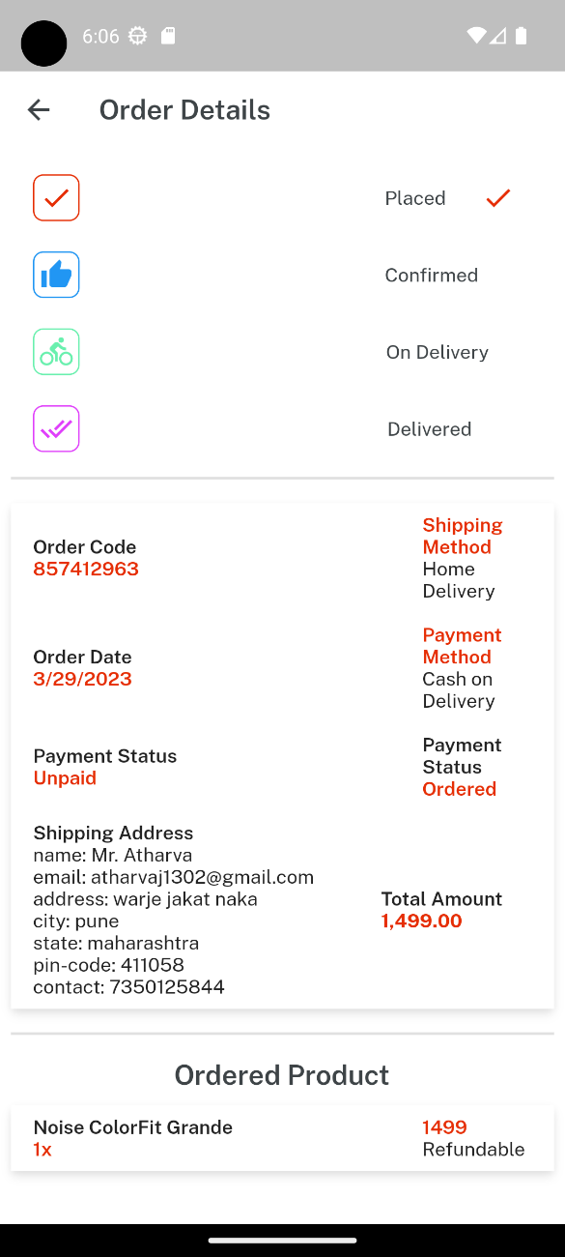

* The orders screen shows all the placed order by the customer. By clicking on the particular order, that orders receipt will be displayed as the image on the right side displays. The receipt is fully dynamic and connected to the admin side. It is manipulated by the admin, in the sense that the admin updates the order status to confirmed,on delivery and delivered. As the admin updates the delivery, the red ticks appear on the respective places [shown in admin side receipt manipulation].
* The order and shipping details are visible below wherein the payment and delivery status get updated through the admin side.

1. Edit profile screen:

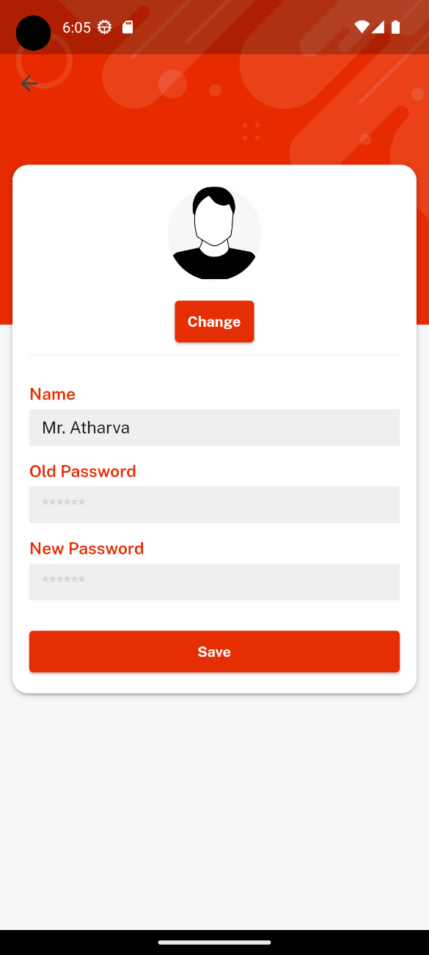

* The edit user page allows the user to set his profile image, change username and update his password.

Admin App:

1. Login page:

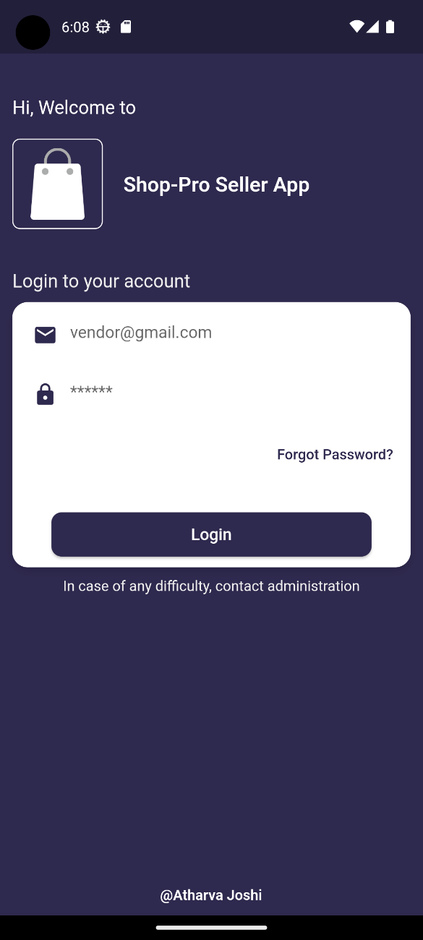

* The login page the admin to log itno the app to manage the application from the backend. The admin app is developed so the admin himself can manage the orders, products from anywhere himself, eleminating the need for the admin to always operated from the computer.

1. Dashboard:

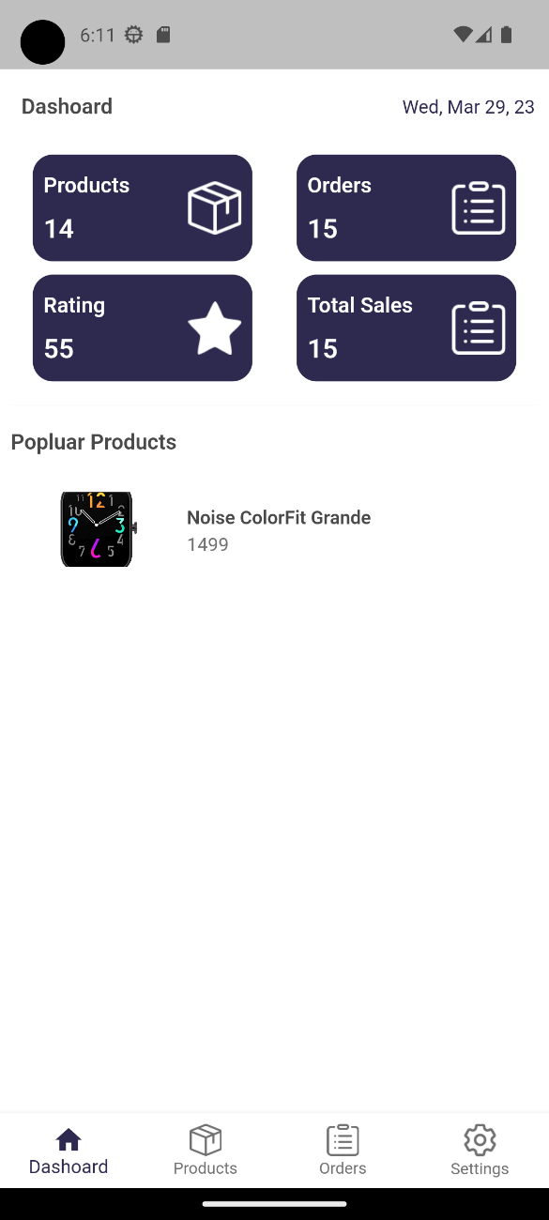

* The dashboard is the landing page after the admin logs into the app. The products counter is only dynamic and the other counters are static in nature. The popular products are updated as the user adds itmes to his wishlist. The use of popular products is that the admin can make the particular product that is popluar an featured product or add it into top products.

1. Products page:

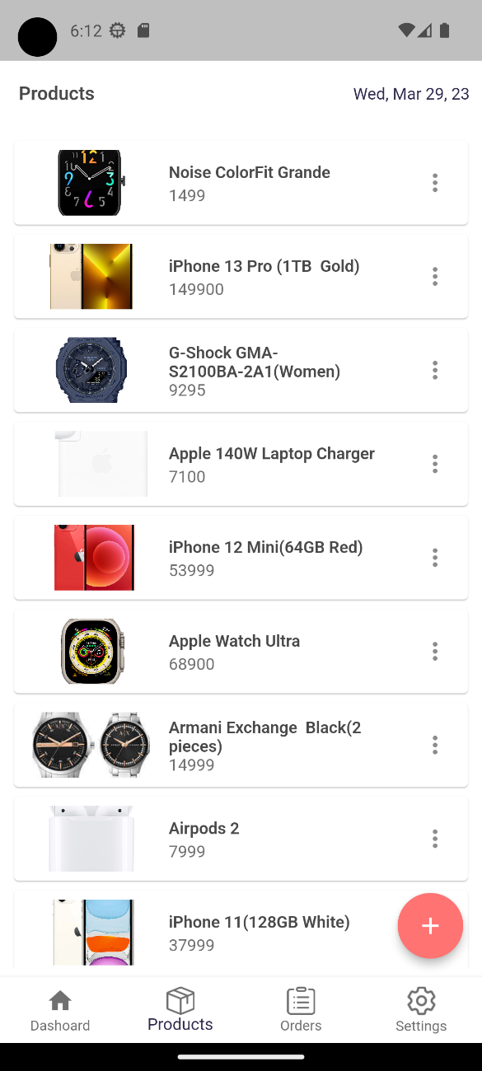 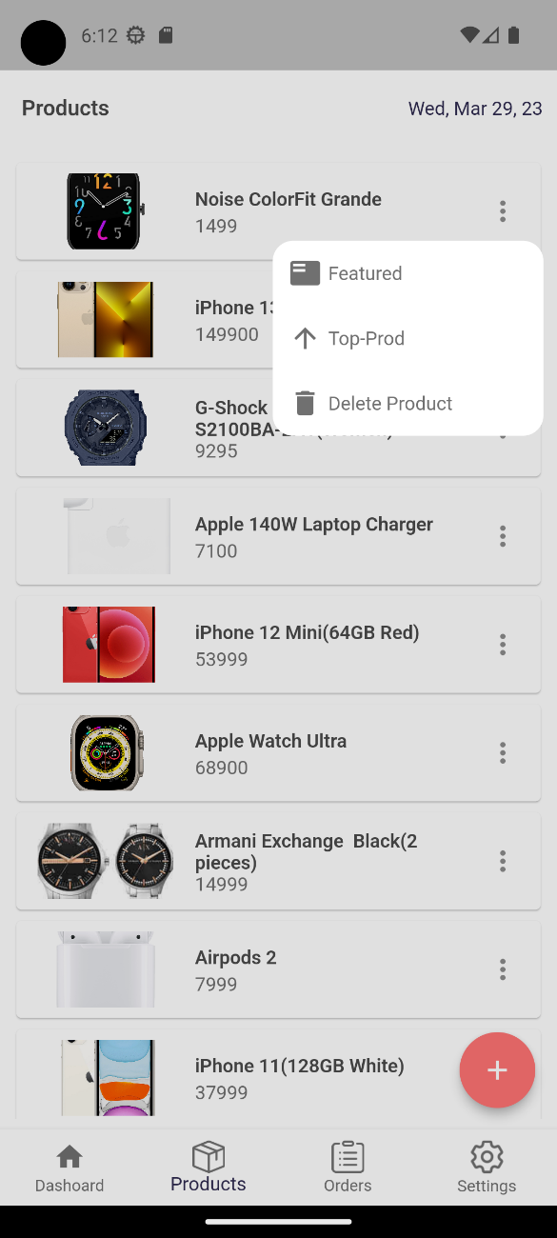

* The product page allows the admin to view the added product and the existing product. On clicking on the three dots the menu on the right displayed image immerges. By clicking on the appropriate buttons the admin can delete a product,make a product featured or add it to the top-product section. The plus icon allows the admin to add a new product to the user application and the added product is displayed in this products seection on the admin side.

1. Add Product page:

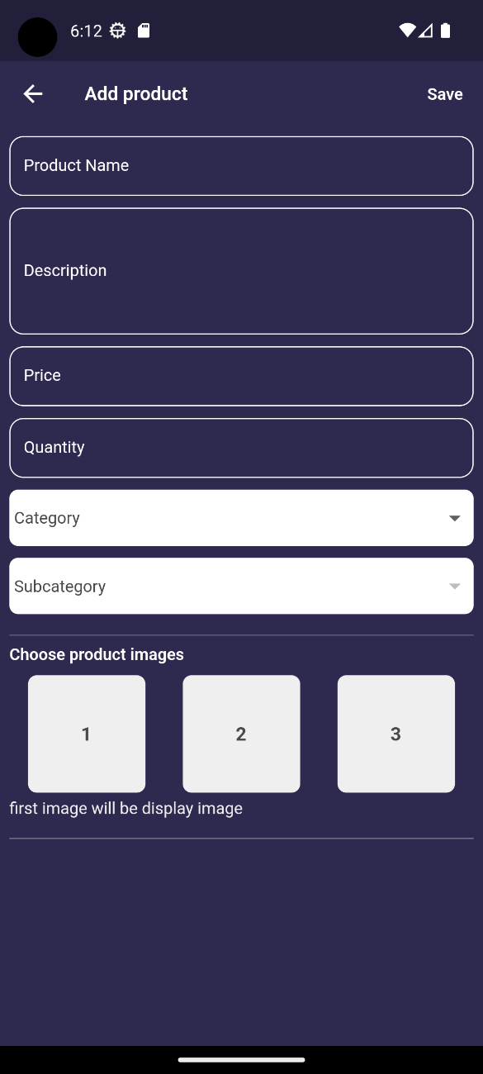

* This page allows the admin to add a new product. Following fields have to be filled while adding a product. After selecting a category to which a product has to be added, only that categories sub category would be visible in the dropdown. The admin can choose upto 3 images out of which the fist chosen image will be the display image for the product.
* By clicking on the save button, the product will be created and added to the user and admin app.

1. Orders and Receipt Page:

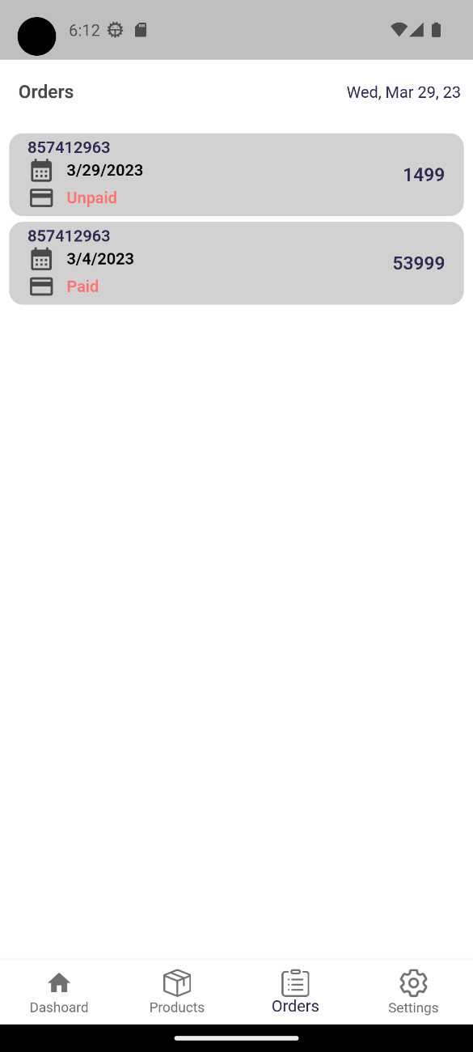 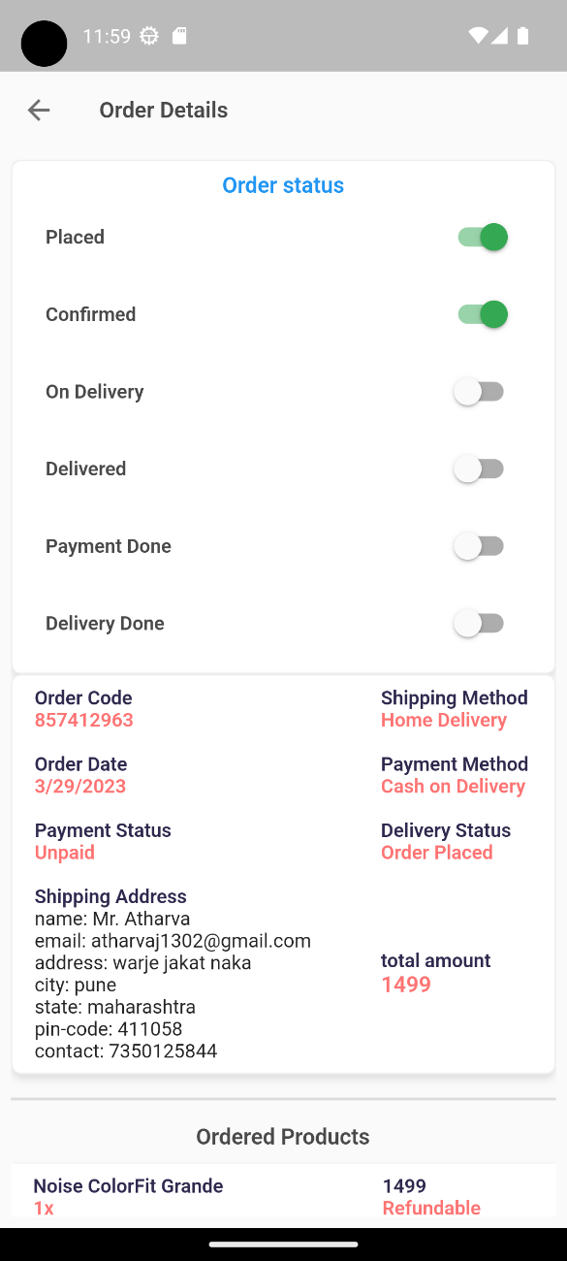

* The admin can manage the orders received from the orders tab. When he clickc on the order a button will appear to confirm the order and he will be redirected to the dynamic receipt which he has to update for order status. The receipt can be updated in terms of delivery status by toggling the buttons in the right side image. As the admin updates the order from his side the receipt on the user side gets updated.

1. Updated Receipt for user:

 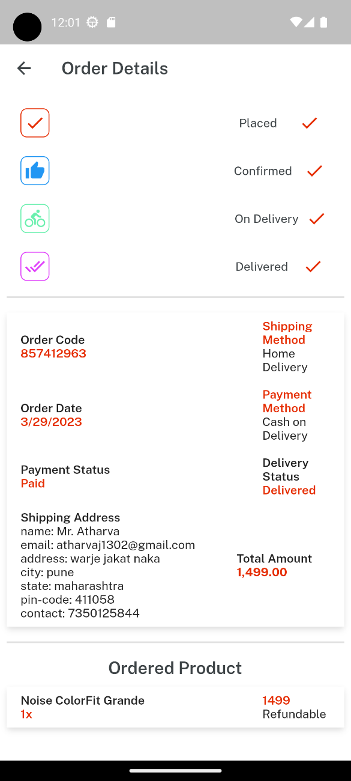

* The receipt on the left side is the one when the order has beenb placecd and not yet confirmed by the seller. As the admin accepts the order and updates its status changes will be reflected in the receipt on delivery and payment status.
* After the admin updates the delivery status and confirms that the order has been paid for and delivered to the customer, the receipt gets updated as shown on the right side.

Diagrams:

1. Data flow diagram:

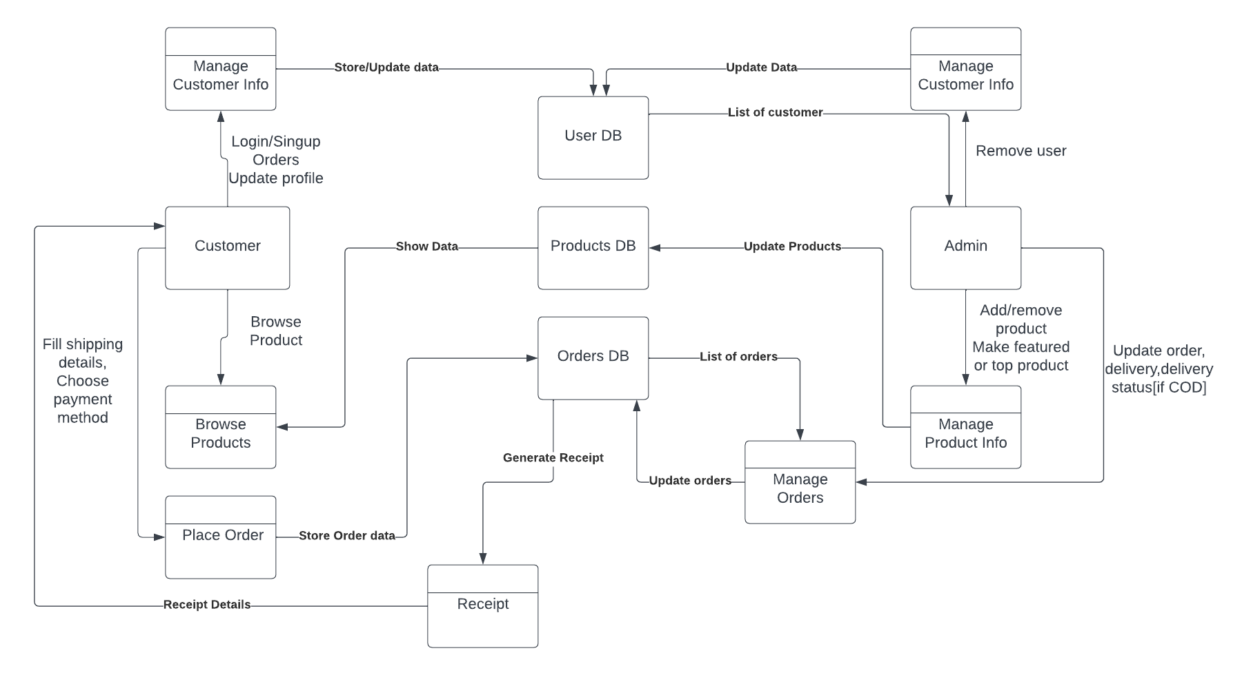

1. Context Level Diagram:

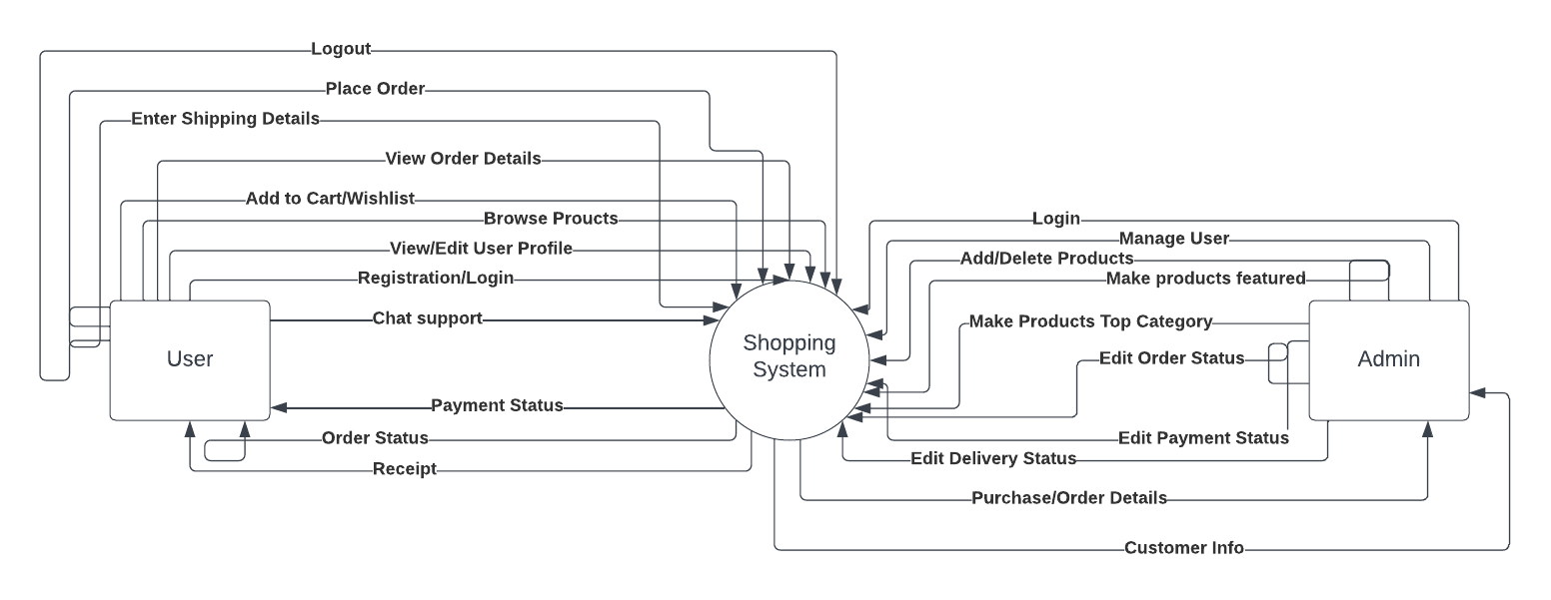

1. Use-Case diagram:

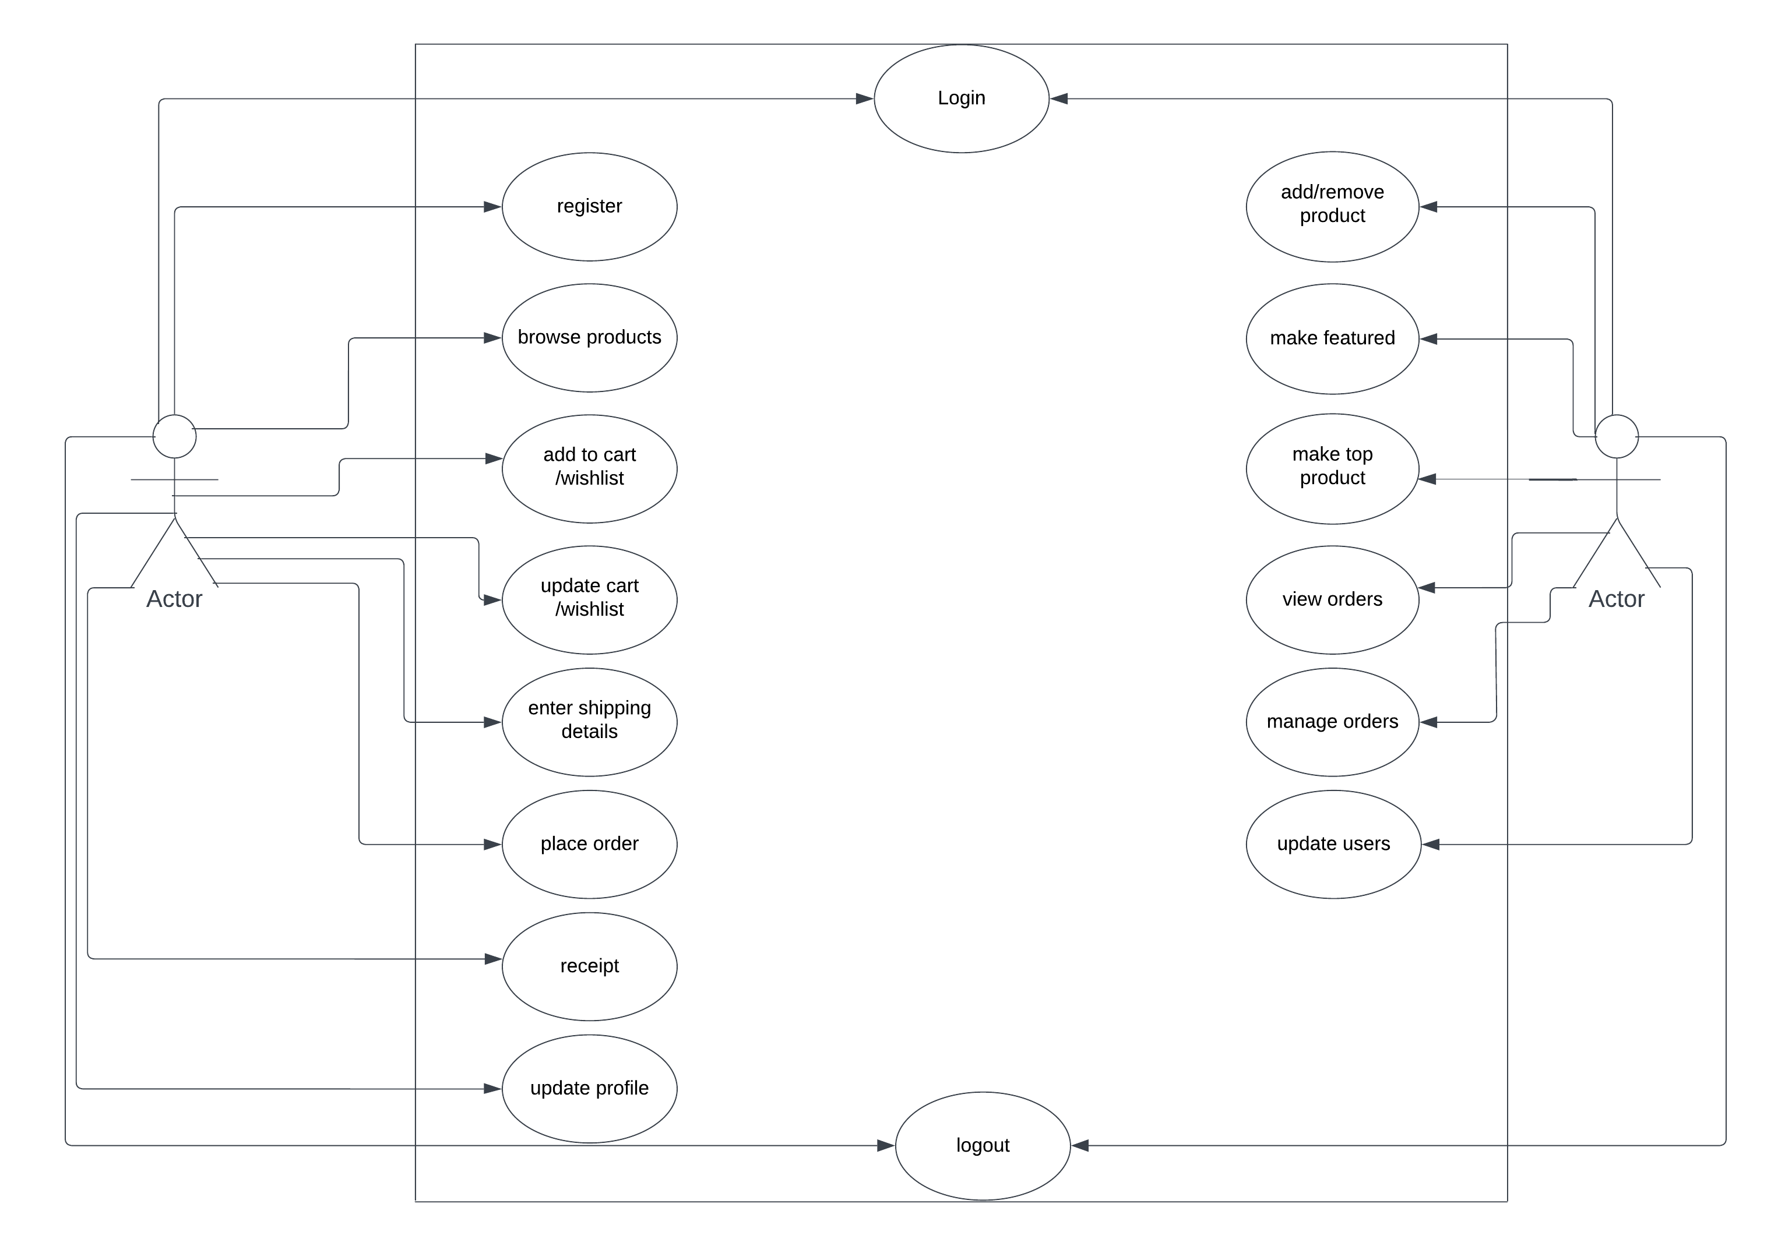

1. Class diagram:

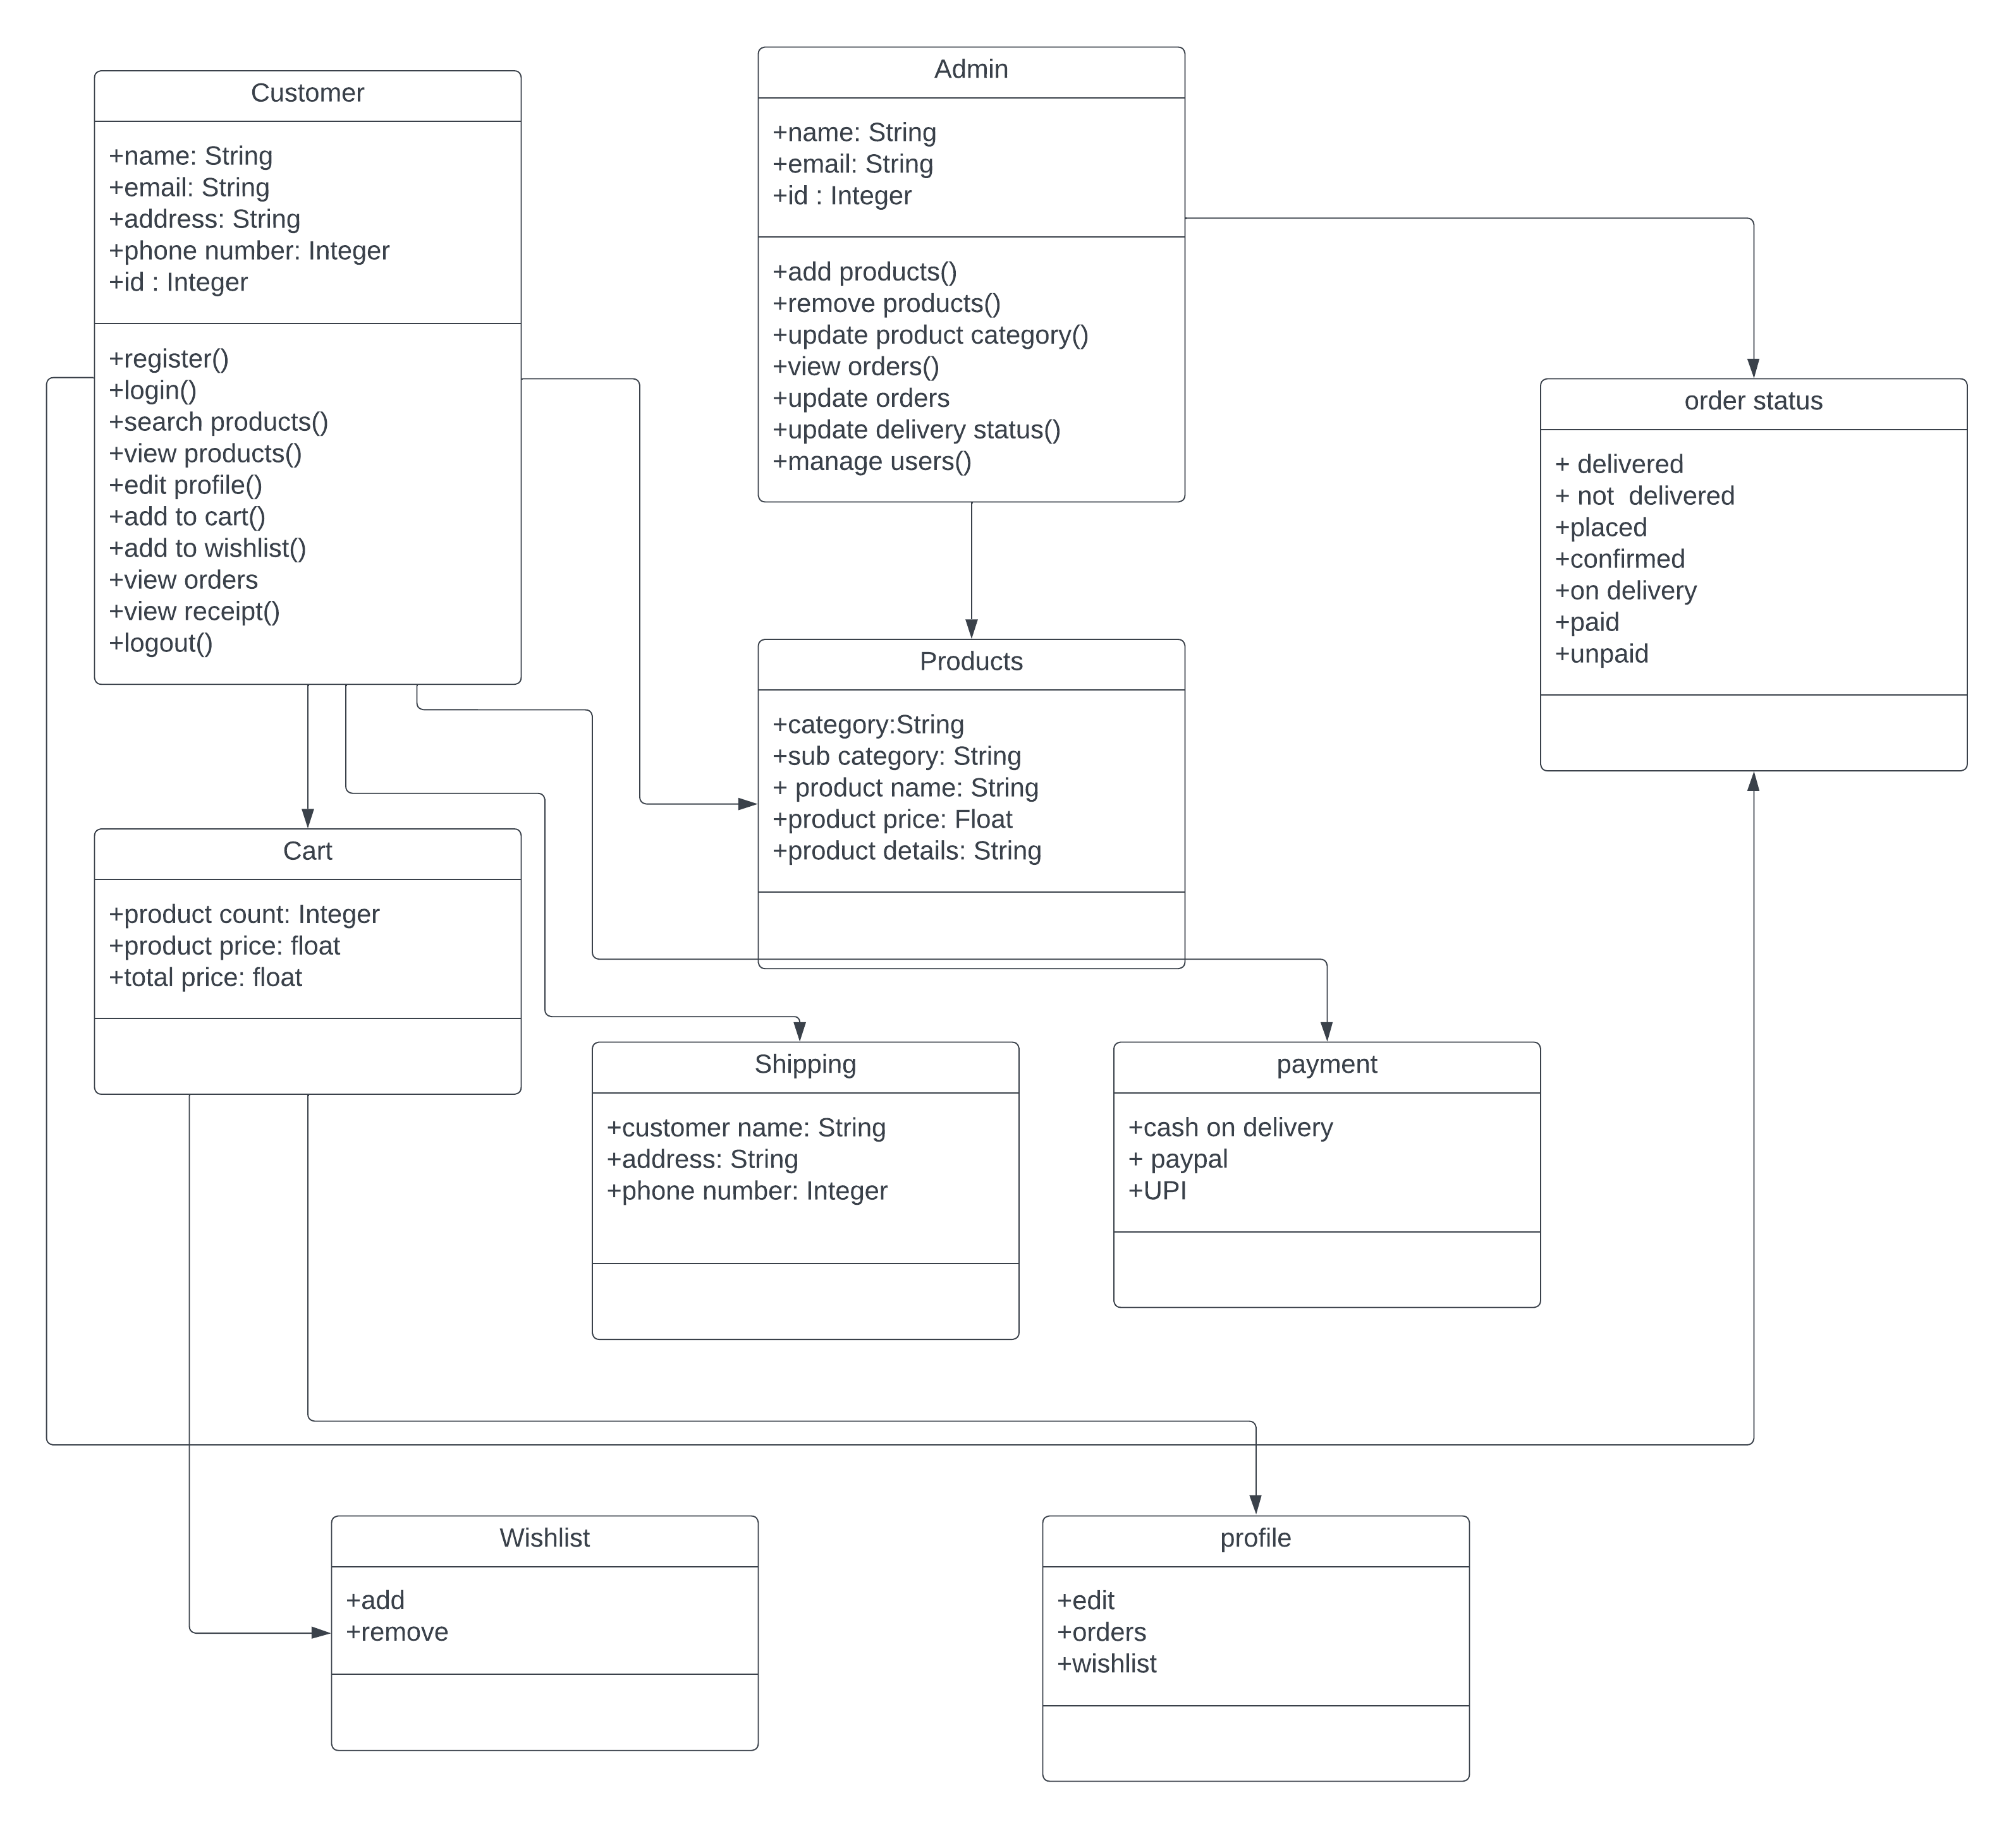

1. Activity diagram:

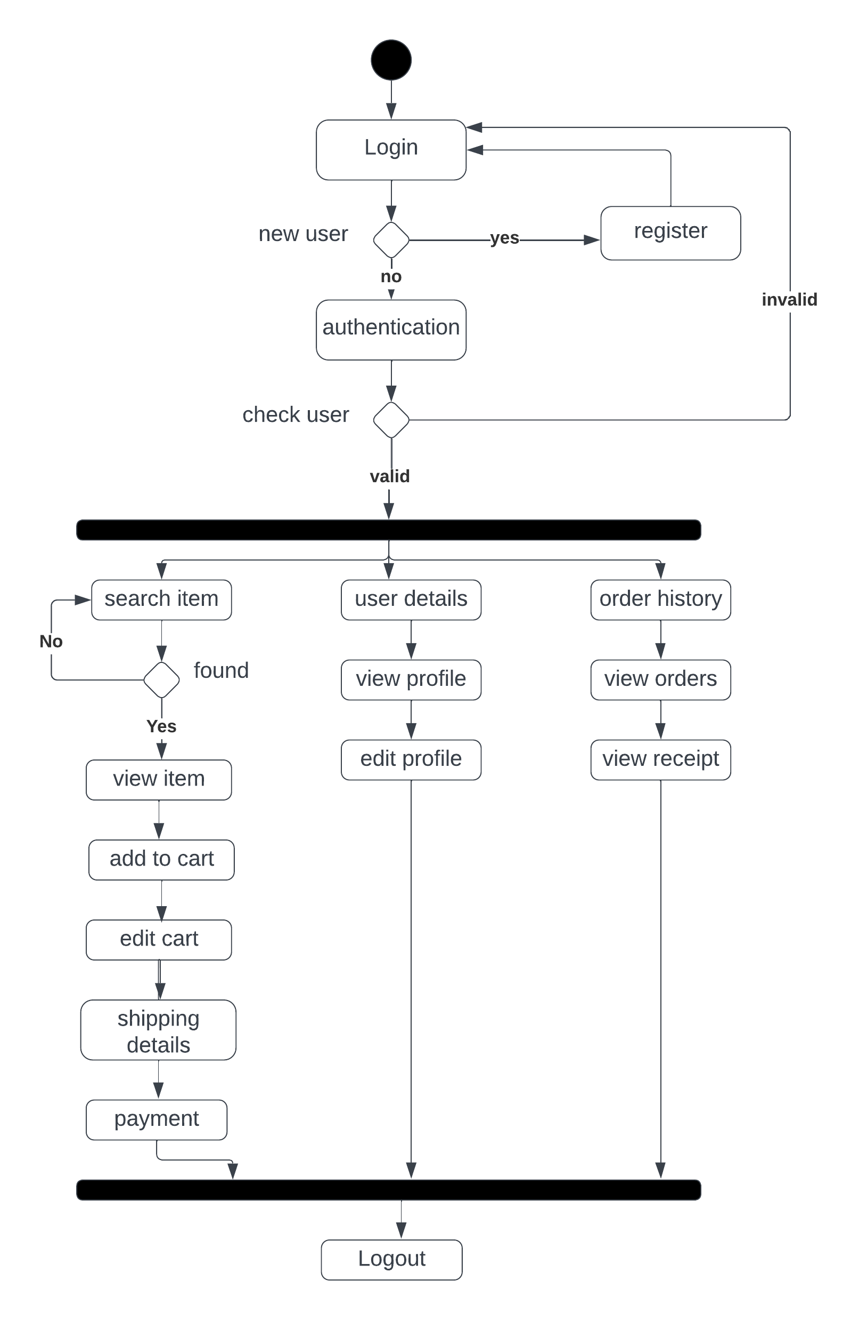

Database Screenshots:

1. Users table:

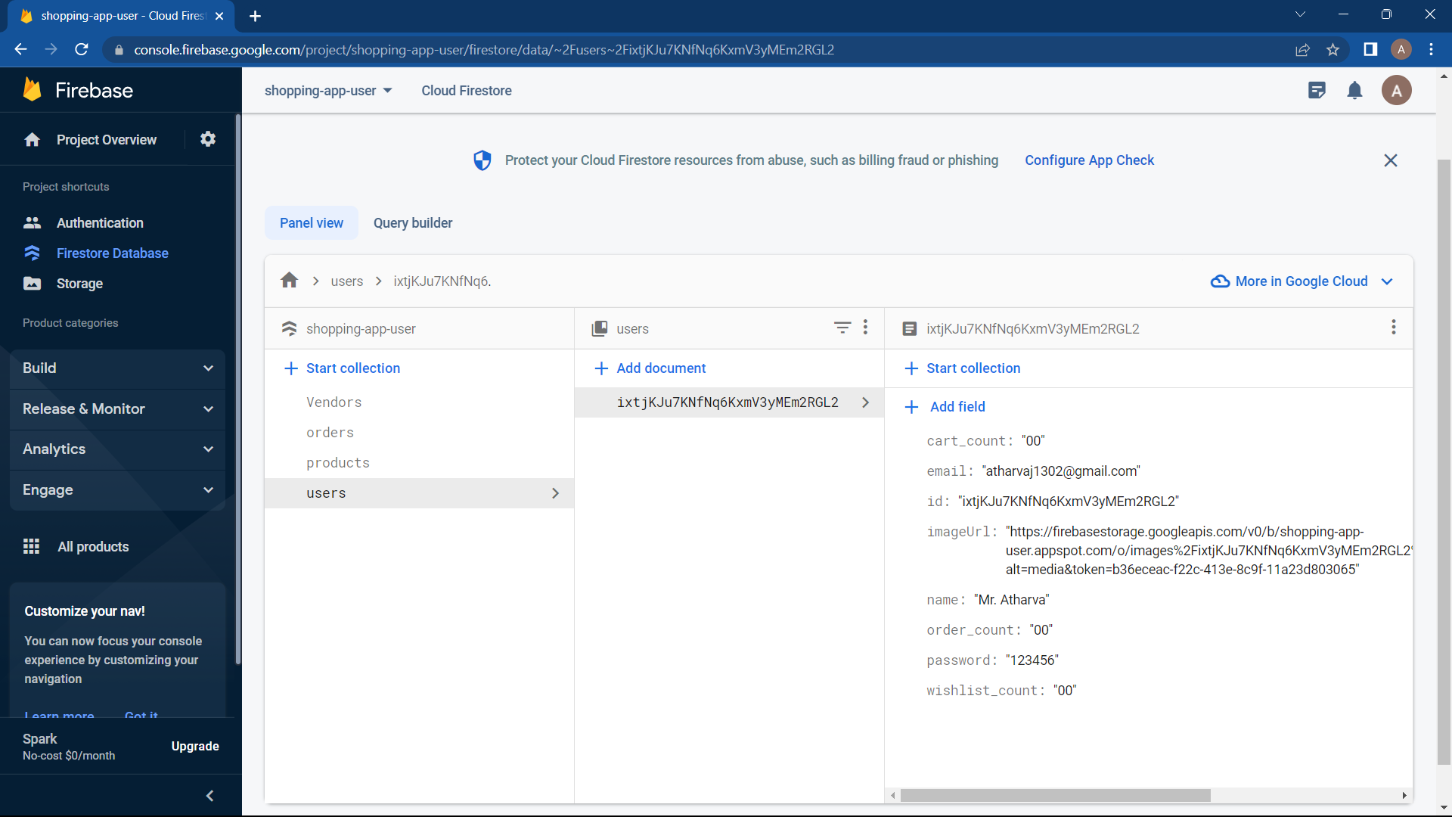

* The users table contains all information about the user such as name,email,items in cart and wishlist, number of orders placed.

1. Products table:

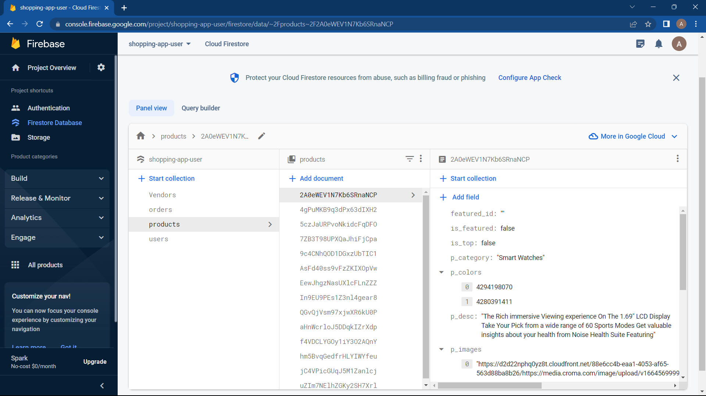

* The product table contains information about the particular products which have their own unique id. It contains information like product description, images,quantity available,is the product featured and so on.

1. Orders table:

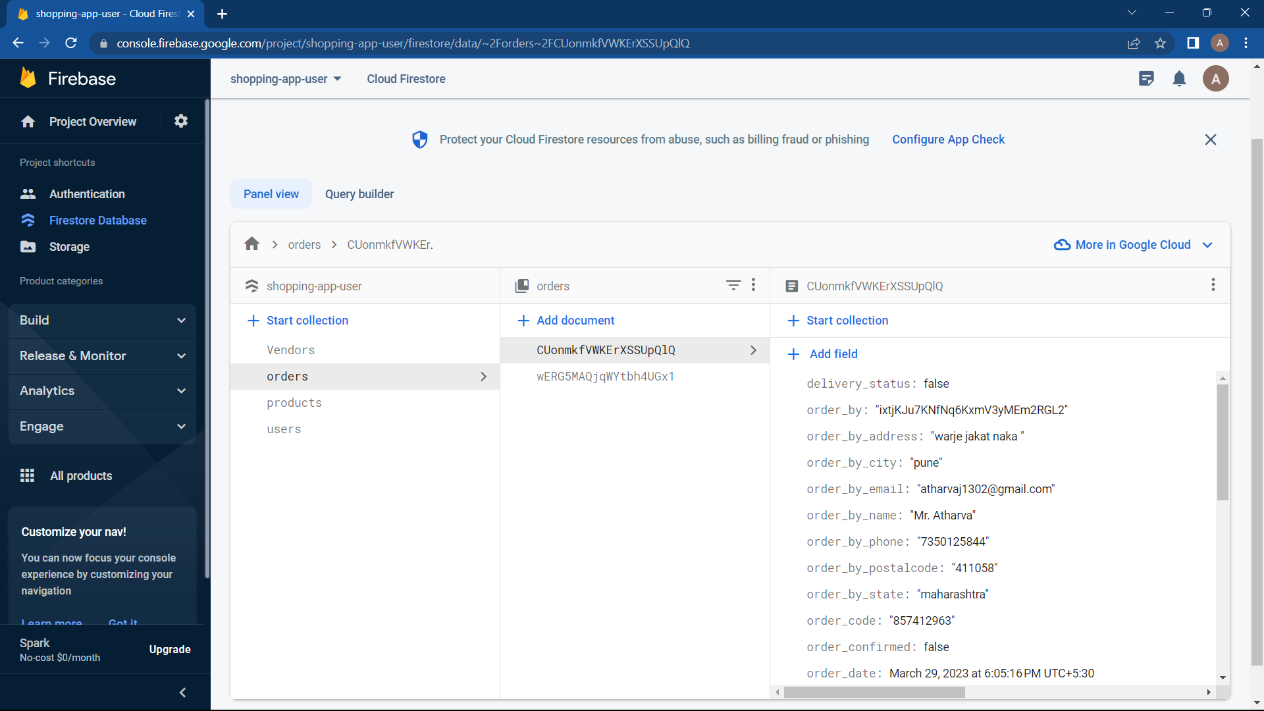

* The orders table contains all the orders placed by the user. It contains information such as the name of user who placed the order,address details, payment mode, product ordered,delivery status,payment status and so on.

1. Vendors table:

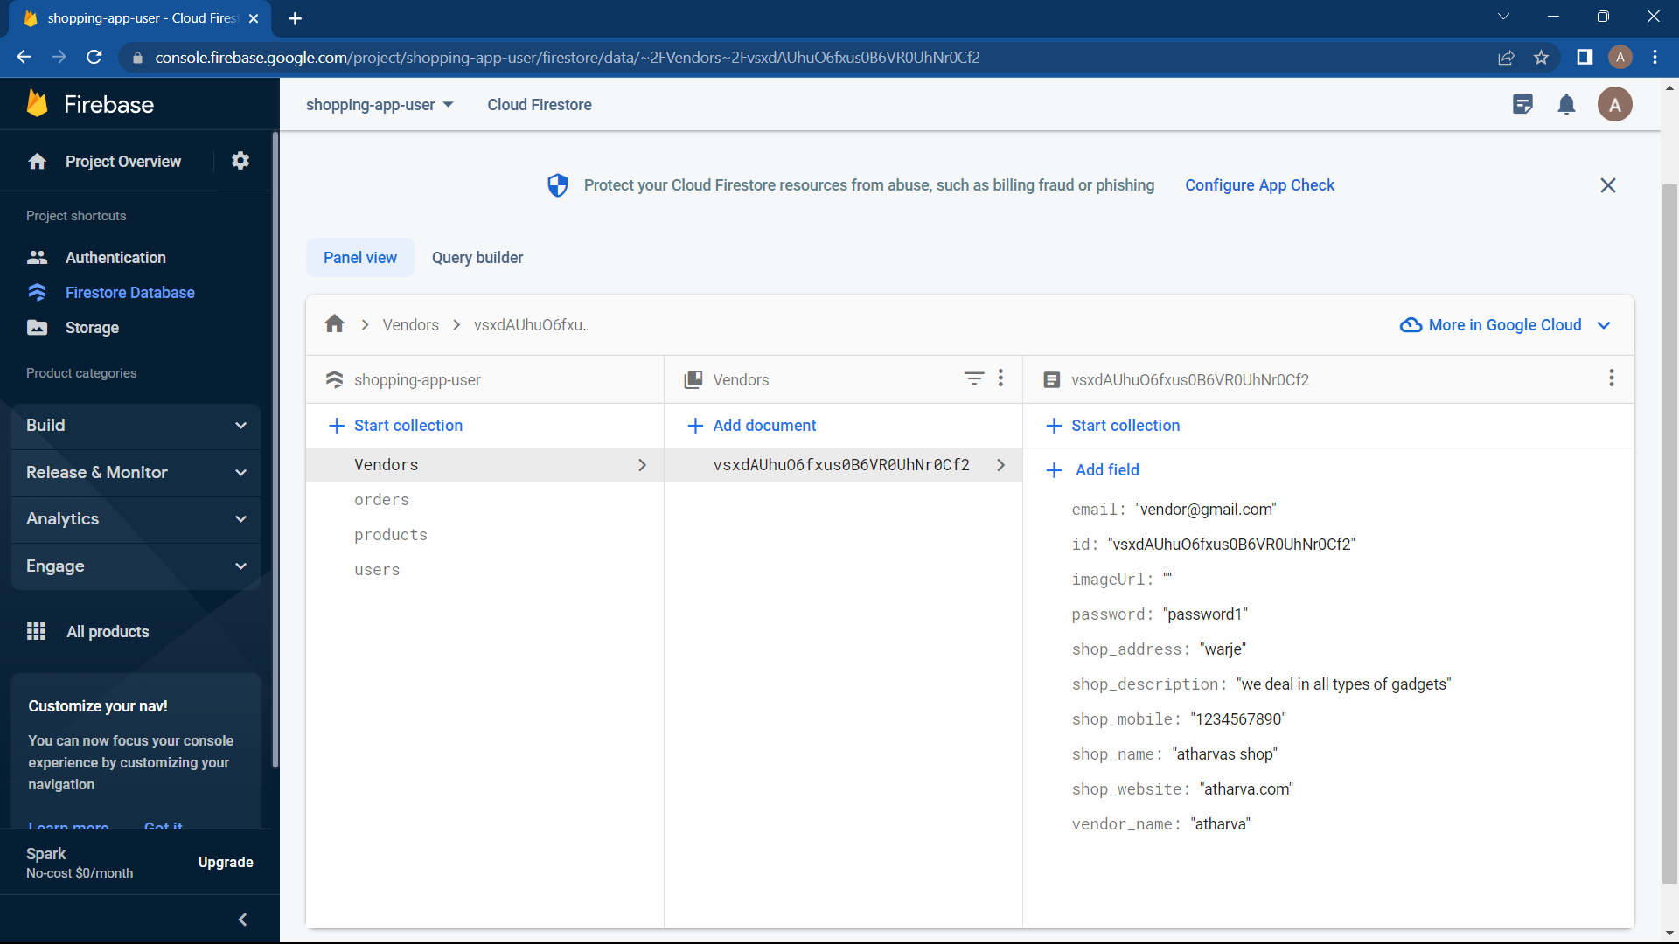

* The vendors table is nothing but the admin who has to be created through the database only.

SOFTWARE TESTING RESULTS:

* Cross device compatibility
* Responsiveness
* Functionality testing
* User validation